Rajesh kumar singh  17th March,1994  ㅡ  Career Objective | Rajesh kumar singh  51/45  N.S.ROAD  RISHRA, HOOGHLY.  PIN :-712248  Contact No :- 8017700039  rjsinghhh@gmail.com  proven knowledge of application development, emerging technologies, and real time data. Aiming to leverage my skills to successfully fill the role of Software Developer role at your company.
ㅡ  Skills | HTML, CSS, JavaScript, Java, C
ㅡ  TRAINING | Title: Vocational Training in Advanced Telecom.  Synopsis: Completed a Vocational Training of four weeks in Advanced Telecom w.e.f 16-06-2015 to 13-07-2015 at Netaji Subhash Chandra Bose Telecom Training Centre, BSNL covering the protocols and principles related to Signaling, Switching and Transmission of information in an Advanced Telecommunication System.  Learning: Advanced Telecommunication Principles.  Location: NSCBTTC, BSNL, Kalyani, Nadia.  Tenure: 16th June-13th July (4 weeks).
ㅡ  College Project | - Did a project on “Bhajan and Mantra chanting” and presented it at a seminar held in the college campus.  - Did a Project titled “Unmanned Aerial Vehicle” which basically deals with flight control with the help of Wireless Communication.
ㅡ  Education | SUPREME KNOWLEDGE FOUNDATION GROUP OF INSTITUTION / B. Tech in Electronics and Communication Engineering  2012-2016  College Affiliated under Maulana Abul Kalam Azad University (formerly WBUT)  Grade: 7.62 CGPA  RISHRA VIDYAPITH HIGH SCHOOL / Higher Secondary  2009-2011  Affiliated under W.B.C.H.S.E  Grade: 52%  RISHRA VIDYAPITH HIGH SCHOOL / Senior Secondary  2009  Affiliated under WBBSE  Grade: 68%

I hereby confirm that the information in this document is accurate & true to the best of my knowledge.

Place: Rishra

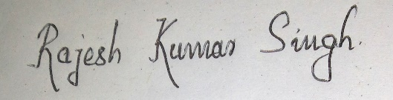

Date: 26th June,2020 ________________

Signature

